Name : Kirtesh Satish Admute
Roll No. : 258039
PRN : 250841220082
Module : DBT

use iacsd0925;

-- Create a table
-- Location(loc_id, lname,address)
CREATE TABLE location (
loc_id int primary key not null auto_increment,
lname varchar(20),
address varchar(20)
);

-- Server (sid,sname,configuration,lid, adminid)
CREATE TABLE server (
sid int primary key not null,
sname varchar(20),
configuration varchar(28),
lid int,
adminid int,
constraint fk_lid foreign key(lid) references location(loc_id)
on delete cascade
on update cascade,
constraint fk_adminid foreign key(adminid) references admin(adminid)
);

-- Admin(adminid,username,password,mobile,name)
CREATE TABLE admin (
adminid int primary key not null,
username varchar(20),
password varchar(20),
mobile varchar(10),
name varchar(10)
);

-- 1. display all server-name, location of the server
SELECT s.sname, l.lname from server s, location l
WHERE l.loc_id = s.sid;

-- 2. display all server-name, admin-name, admin mobile
SELECT s.sname, a.name, a.mobile
from server s
inner join admin a on a.adminid = s.adminid;
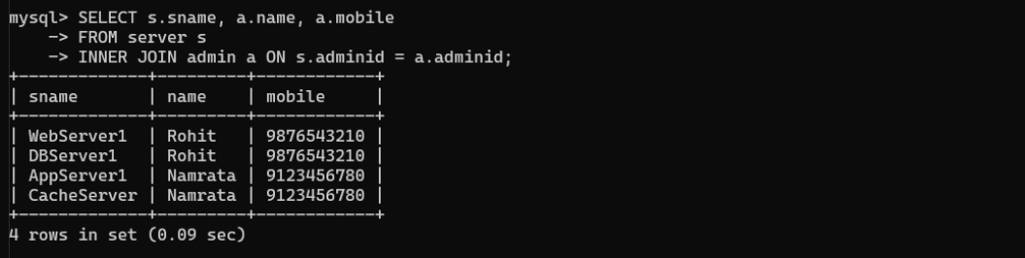

-- 3. display all server which are managed by admin rohit
SELECT * from server
where adminid in (SELECT adminid from admin where name = 'Rohit');
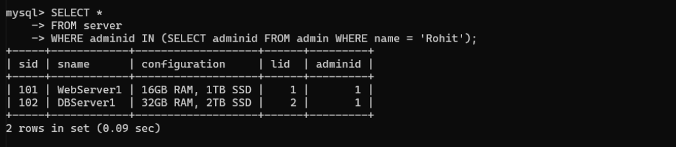

-- 4. display all server and the locations,for which admin is rohit
SELECT s.sname, l.lname from server s
inner join location l
on s.lid = l.loc_id
WHERE s.adminid in (SELECT adminid from admin WHERE name = 'Rohit');
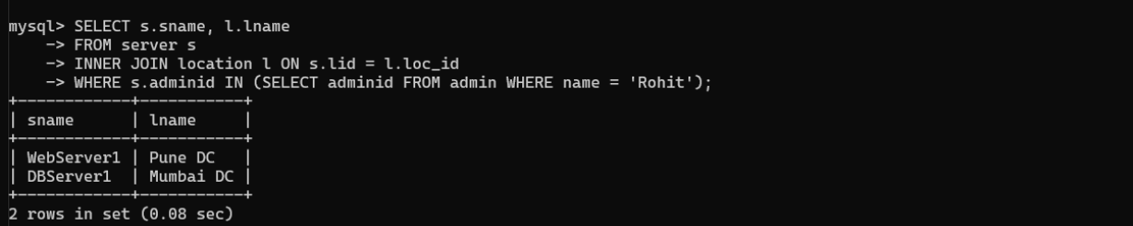

-- 5. display all admins, for whome no server is assigned
SELECT * from admin a
left join server s
on a.adminid = s.adminid
where s.adminid is null;
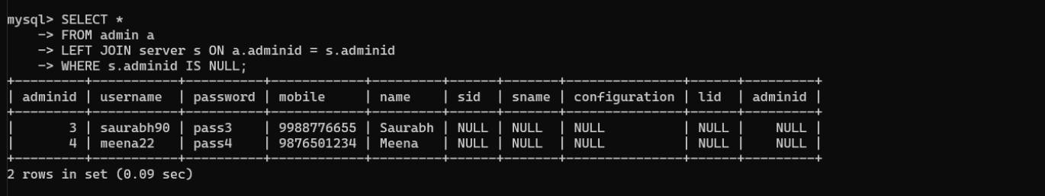

-- 6. display all servers and admin details, and also display admins for whom no server is assigned
SELECT * from server s
right join admin a
on s.adminid = a.adminid
where s.adminid is null

UNION

SELECT * from admin a
left join server s
on a.adminid = s.adminid
where s.adminid is null;

SELECT s.sname, a.name, l.lname FROM server s
INNER JOIN location l ON s.lid = l.loc_id
INNER JOIN admin a ON s.adminid = a.adminid;

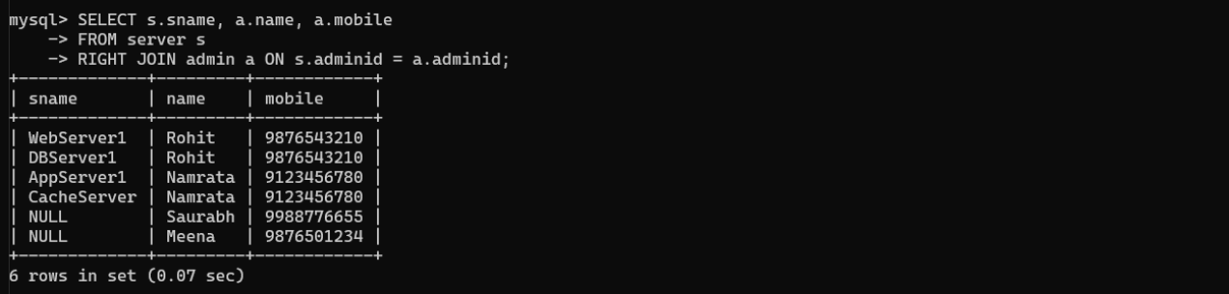

-- 8. to display all admins for whom no server is assigned also display locations at which no server is placed
SELECT * from admin a
left join server s
on a.adminid = s.adminid
where s.adminid is null;

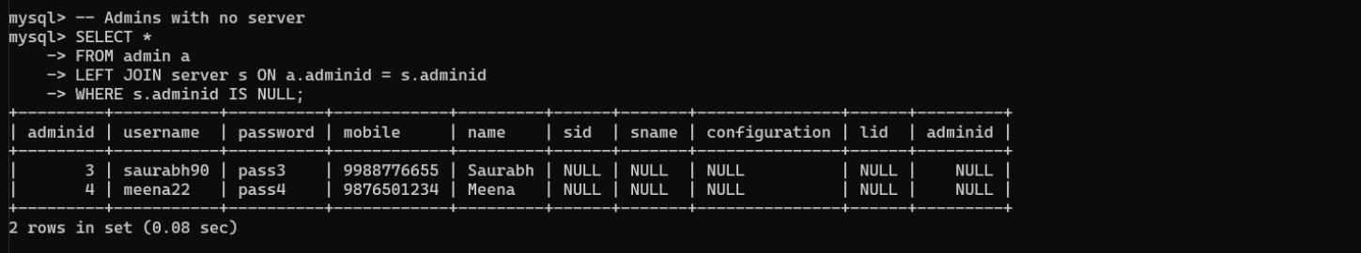

-- 9. display all servers for which no location is assigned
SELECT * from server s
LEFT JOIN location l ON s.lid = l.loc_id
WHERE l.loc_id IS NULL;
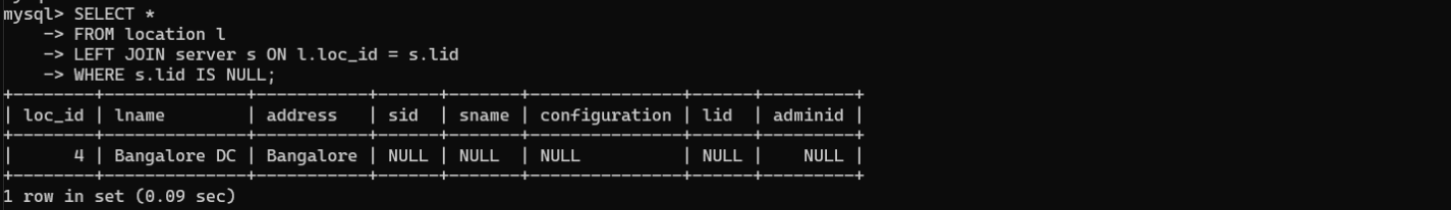

-- 10. display all servers, for which no location is assigned, whose admin is namrata
select s.sname, a.name, l.lname from server s
INNER JOIN location l ON s.lid = l.loc_id
INNER JOIN admin a ON s.adminid = a.adminid
WHERE s.adminid in (SELECT adminid from admin WHERE name = 'Namrata');
